Auction Site

Miranda, Austin, Sam

Table of Contents

Prerequisites

The design of the lab is to run a webpage whose authentication must go through Windows IIS as well as Apache on a Linux laptop or computer and provide full functionality to the user when they log onto the webpage.

For this project virtual machines will be used to host all required operating systems but computers who already host the OS’s will work too. Prerequisites for the project include two virtual machines, one which will host a Windows server 2016 operating system and another which will host Linux Ubuntu. Features that will be added into the Windows Server virtual machine include IIS, and MySQL which will be used to make the database that will be used to provide information to the website. For the Linux Virtual machine, you will need to install php, Apache and if you do this in a group and are using github to share documents, GitHub desktop can also be installed.

For full functionality of the website, the goal is to have the page display multiple categories and items within each category. When a user clicks a category, only currently available items will be displayed. You can create an account on the site. A user will be able to correctly place a bid for an active item and each item will be complete with pictures as well as add a new item which will also have pictures. Lastly, the winner of an auctioned item will receive an email describing the item they have won and the price point in which the item was purchased for.

Installation

* Linux Ubuntu Virtual Machine

As stated in the prerequisites portion, the Linux Ubuntu virtual machine will hold php, Apache and if required by a team of people who are using GitHub, we will show those installation steps as well.

Once you create your virtual machine with Ubuntu, we will launch the terminal either by going into “show applications” and finding “terminal” or you can use CTRL+ALT+T. Once the terminal is up, we will install Apache. Apache is the IIS equivalent for Linux users. The commands for installation are:

NOTE: You will be asked by certain commands for a [Y/n], you will always select Y as it will execute and install the command you are trying to perform.

**sudo apt update** (this will check to see if updates are available within your OS)



**sudo apt install apache2**(Once the OS is updated, this will install the Apache service onto your OS)



When you install Apache, added by default is /var/www/html which is where you can store php files that will be used for the website.

The following command will be used to change/gain ownership of the /var/www folders so the specified user can have full access to files in any directory in the /var/www path.

**sudo adduser <username> www-data; sudo chgrp -R www-data /var/www; sudo chmod -R g+rw /var/www; find /var/www -type d -print0 | sudo xargs -0 chmod g+s**



NOTE: Once this command is finished running, you must log out and back into Ubuntu for the user permissions to take effect on files (if any) located within that directory.

PHP is a file type in which if a single line of code uses the <?php ?> tag, that file must be saved as a PHP. This will be the file type for all files within this project and installing php will allow users to properly run the code. To install php type the following commands:

**sudo apt upgrade** (Upgrade installs the updates available)



**sudo apt update** (this will check to see if updates are available for current packages on the OS)



**sudo apt install php7.4**(Installs the version of php you would like to use)



**sudo apt install php-mysql**(Implements php into mysql database)



**sudo service apache2 restart**(Restarts the package for full integration between php and apache)

This will install php on Ubuntu and the purpose for restarting services is to fully integrate php into the Apache service.

GitHub Desktop is a program you can download from the internet that provides version control to any document that is changed during the history of a project. This means you are able to see what people have deleted and added to a file as well as how it has affected the file. If this is what you group is using, here are the steps to installing GitHub Desktop onto Ubuntu:

**wget -qO - https://mirror.mwt.me/ghd/gpgkey | sudo tee /etc/apt/trusted.gpg.d/shiftkey-desktop.asc > /dev/null** (to install GitHub Desktop, a certificate is required which is the purpose of this command)

You will be presented with two options for the next command as there is a “mirror” and “packagecloud” command. In this project we will be using the mirror command due to its “infinite bandwidth” capability.

**$ sudo sh -c 'echo "deb [arch=amd64] https://mirror.mwt.me/ghd/deb/ any main" > /etc/apt/sources.list.d/packagecloud-shiftkey-desktop.list'**

If you were to choose to use the packagecloud, the code is:

**$ sudo sh -c 'echo "deb [arch=amd64] https://packagecloud.io/shiftkey/desktop/any/ any main" > /etc/apt/sources.list.d/packagecloud-shiftkey-desktop.list'**

Lastly, you will perform an update and install GitHub desktop onto your Linux Virtual machine.

**$ sudo apt update && sudo apt install github-desktop**

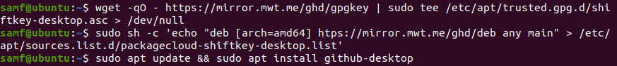

-Windows Server 2016

The first thing that needs to be installed onto the Windows server vm is IIS, which is a web server you can install on any Windows server OS. The installation process is:

Go onto the dashboard in server manager and click on “Roles and Features”



In the wizard, you will select installation types, and what server the role will be installed on. Once you reach “Server roles” scroll till you find IIS and select the check box to install it.



Lastly, continue to click next in the wizard until you add the role and click finish to close the wizard.

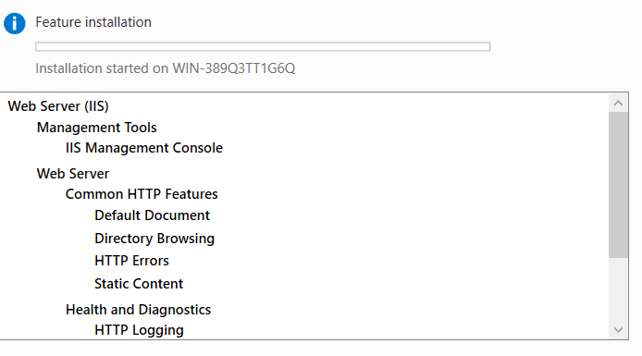

Secondly you will need to install mysql onto windows server which is able to be downloaded off the internet. The other option you have is getting the installer from another person who already has mysql downloaded.

To get the installer, go onto <https://dev.mysql.com/downloads/installer/> and install the web community version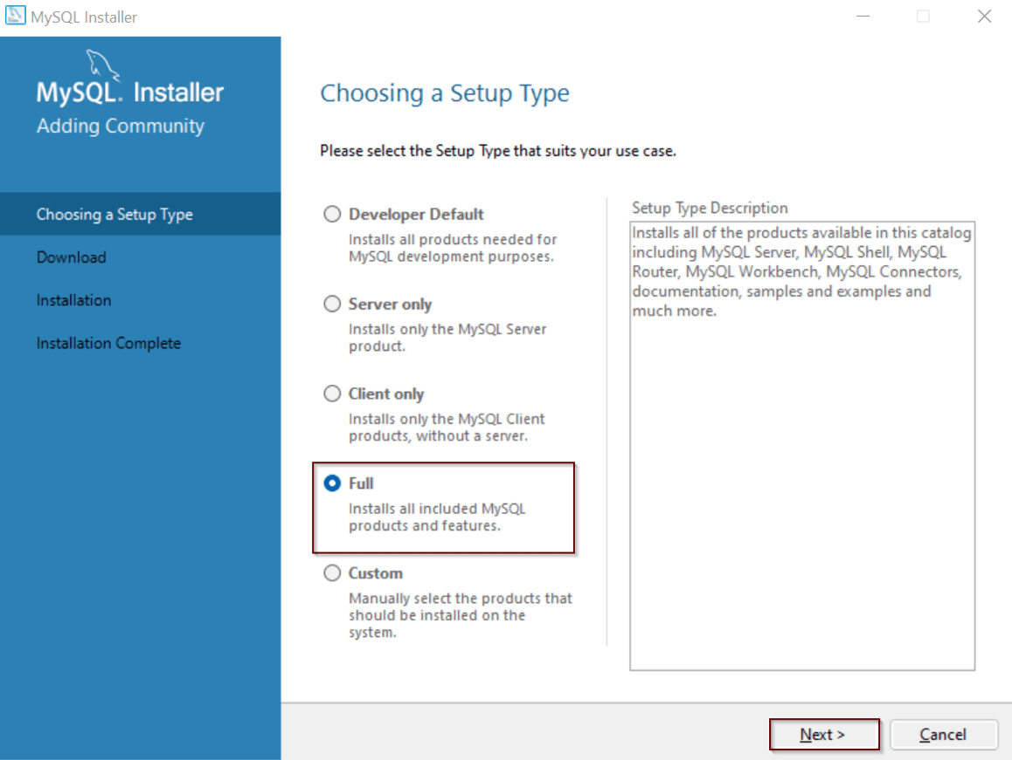 Launch the installer once it is downloaded and you will be presented with installation type options, for this project I used the default selected installation type “Developer Default”.

You will then be presented with download and installation screens which will show you what will be downloaded based on the installation type and you will then install each download onto the virtual machine.

After installations are complete, you will have to configure authentications for a root account, as well as setting a DB admin. You may also need to run a couple other authentications, which can be found if you simply relaunch the installer and see a “reconfigure” link next to a download.



NOTE: The reconfigure link will not go away once it has been “reconfigured” all you need to remember is the appropriate passwords to accounts.

Working with Code

For this project we were provided with a book describing functionality as well as the php sample codes. In theory, the code provided should provide full functionality to the user assuming all other parts work correctly. In this case, the term “other parts” refers to database creation and implementation.

As stated, the book provides php code that should provide functionality. However, the code has inconsistencies within itself which does not give the expected functional outcome. Due to these inconsistencies, changes to the code are required, some of which are not originally described within the book.